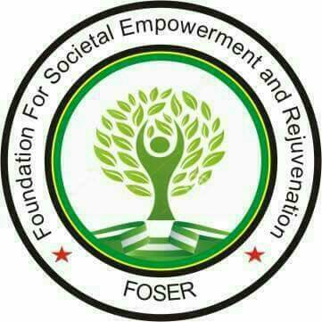
FOUNDATION FOR SOCIETAL EMPOWERMENT AND REJUVENATION & PARTNERS

ORGANIZED A
STAKEHOLDERS ENGAGEMENT AND DIALOGUE MEETING
DATE: 04TH AUGUST 2022
VENUE: YIMIR HOTELS, BAUCHI

The Foundation for Societal Empowerment and Rejuvenation and partner organization has organized a one-day Stakeholders Engagement meeting with security and community stakeholders comprising of representatives of Police, Civil Defense Corps, Federal Road Safety Corps, traditional/religious leaders, Community vigilante group, National Human Right Commission, Ministry of Justice, Lawyer, Media, women groups, youth groups, and rightsholders.
The meeting was centered on the roles of Security Agents and Citizens in Promoting Human Rights which is a strategy to harness the roles of stakeholders as well as strengthen participation of citizen in promoting human rights in Bauchi.
Although Nigerian police force are constitutionally responsible for the protection of lives and properties of the citizens but the insecurity challenges bedeviling the country is on the increase and it can be attributed to several reasons, first the ratio of police currently is 1 to 737, this number is insufficient to provide effective security services to the large population of Nigerians and to tackle the myriads of problems the Nigerian Police are facing such as kidnapping, human trafficking, banditry, murder, vandalization to mention but a few. In addition, citizens themselves in a way consciously or unconsciously contribute to the decadence obtainable in the police force due to lack of value attached to police work which is reflected often by recommending or sending unqualified members of the society to join the Police Force. Also, often some of these recommended persons from the society to join the police are most times over aged people who cannot be easily train. The implication of having unqualified persons in the police force will continue to pose a threat to lives or brutality to the citizens except it is addressed.
Furthermore, there is lack of trust between the police and the citizens, the society’s perception of the police is negative, often viewed as corrupt, brutal, insensitive, illiterate, dirty and untrained. The police on the other hand, for example with the End Sars experience find it difficult to trust the citizens, again, the community sometimes hide criminals, all these continues to pose a threat to human security and contributes to the violation of human rights.
There is the need to recruit the right people into the police force, build trust in the security system, raised awareness for people to know their rights, periodic town halls meetings and shared the police contact address, and social media handles in which the police can be reached easily in the state. The participants were further enjoined to know that human rights are natural and universal attributed to all humans. Though it is the rights of the police to protect lives and properties as enshrined in the Nigerian Constitution and other Rights instruments, the police alone cannot do it. Thy need the cooperation of the citizens which begins with them knowing those rights such as right life, freedom of movement, freedom of expression, right to liberty, right to fair hearing, freedom from discrimination, right to privacy, right to dignity, freedom of thought and freedom of lawful assembly and so on.
At the end participants were clustered in to four groups (CSO’s and PWDs, Human right activist and media representative, Religious and Community Leaders, and Security Agents) and come up with draft document and presented by each group.
The groups presentations were collated and harmonized as a communique at the end of the meeting with the plans of presenting to the government, security agencies, state actors, community and religious leaders and other Civil Society Organization.
This Communiqué was drafted and presented by various categories of groups that were brought in clusters as stated earlier. The groups’ resolutions on how to continue with the promotion of human rights in Bauchi communities are outlined as follows:

- The Religious and Traditional Leaders
- To promote Zauren Sulhu within Bauchi communities which comprises of the religious leaders, youths and women.
- Advocate for the implementation of their constitutional rights and responsibilities in order to promote the issue of human rights.
- We will work in partnership with other stakeholders to train local security agents for the promotion of human rights and others by the stakeholders.
- Promote Community orientation through dialogue and sensitization.

- The CSOs, Human Right Commission and PWDs
- Raise Awareness on Human Rights.
- Advocacy/Collaboration with Rights Stakeholders, and capacity building for security agents
- Sensitize the community members on their fundamental Human Rights or Promote Human Rights through awareness creation
- Report and document human rights violations and abuse
- Writing petitions on behalf of victims of human rights violations and abuse
- Refer victims of abuse to appropriate service providers
- Awareness creation via media
- Monitoring and evaluation
- Youth Groups Representatives
- Advocacy of fundamental human right
- Advocate for youth (both gender) inclusion in decision making in communities (Zauren-Sulhu) as youths are majorly the victims of violation of human right
- Advocate for the strengthening of civic education in schools and local communities
- Advocate and promote ways for accessing justice.

- Law Enforcement Agencies
- Collaborate with CSOs to create awareness on the provisions of laws that promotes human rights
- In case of violation or abuse of human rights, members of the public can contact servicom units in different law enforcement outfit offices or directly call the following agencies on these lines: FRSC Toll Free Hotline 122, NSCDC 07039567362, and Vigilante 09030161967. Social media handles include Facebook: Nigeria Police Force Bauchi State Command; Play Store App: Nigeria Police rescue
- Collaborate with CSOs to step down trainings and seminars to security agencies
- CSOs/Security agencies should enlighten securities agents on the rules of engagement.
- Innovate Strategic Programs on building trust between security agents and citizens. Also strengthen relationship and communication for intelligence gathering and information sharing.
- In collaboration with CSOs, sensitize citizens on the importance of standing for their rights and report any human rights violation and abuse.
- Collaborate with the CSOs to sensitize citizens on the need to be smart and maintain good manner when engaging with security agents.

This communiqué is signed by:

The Representative of Law Enforcement Agents
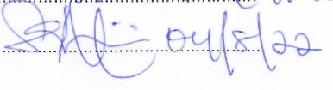
Name: SANI MUHAMMAD INUWA
Sign and Date:

The Representative of CSOs, Human Right Commission and PWDs
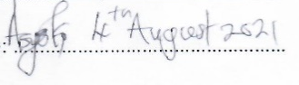
Name: ASMA’U YAHYA
Sign and Date:

The Representative of Religious and Traditional Leaders
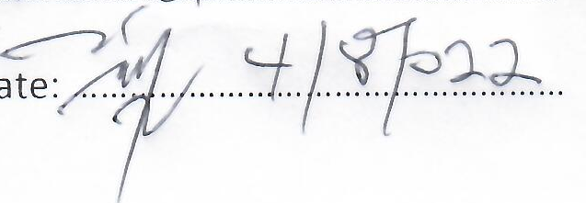
Name: USAMA MUHAMMAD.
Sign and Date:

The Representative of Youth Groups
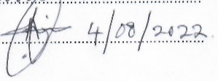
Name: ABDULSALAM SALEH.
Sign and Date:

The Representative of FOSER and the Consortium
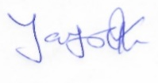
Name: YAYOCK BERNARD
Sign and Date:

